# 

**Flight Price Prediction Project Report**



Submitted by:

**Shikha Chaudhary**

**ACKNOWLEDGMENT**

I would like to express my deepest gratitude to my SME (Subject Matter Expert) Shubham Yadav as well as Flip Robo Technologies who gave me the opportunity to do this project on Flight Price Prediction, which also helped me in doing lots of research wherein I came to know about so many new things especially the data collection part.

Also, I have utilized a few external resources that helped me to complete the project. I ensured that I learn from the samples and modify things according to my project requirement. All the external resources that were used in creating this project are listed below:

1) <https://www.google.com/>

2) <https://www.youtube.com/>

3) <https://scikit-learn.org/stable/user_guide.html>

4) <https://github.com/>

5) <https://www.kaggle.com/>

6) <https://medium.com/>

7) <https://towardsdatascience.com/>

8) <https://www.analyticsvidhya.com/>

**INTRODUCTION**

* **Business Problem Framing**

The airline industry is considered as one of the most sophisticated industry in using complex pricing strategies. Nowadays, ticket prices can vary dynamically and significantly for the same flight, even for nearby seats. The ticket price of a specific flight can change up to 7 times a day. Customers are seeking to get the lowest price for their ticket, while airline companies are trying to keep their overall revenue as high as possible and maximize their profit. However, mismatches between available seats and passenger demand usually leads to either the customer paying more or the airlines company losing revenue. Airlines companies are generally equipped with advanced tools and capabilities that enable them to control the pricing process. However, customers are also becoming more strategic with the development of various online tools to compare prices across various airline companies. In addition, competition between airlines makes the task of determining optimal pricing is hard for everyone.

Anyone who has booked a flight ticket knows how unexpectedly the prices vary. The cheapest available ticket on a given flight gets more and less expensive over time. This usually happens as an attempt to maximize revenue based on

1. Time of purchase patterns (making sure last-minute purchases are expensive)
2. Keeping the flight as full as they want it (raising prices on a flight which is filling up in order to reduce sales and hold back inventory for those expensive last-minute expensive purchases)

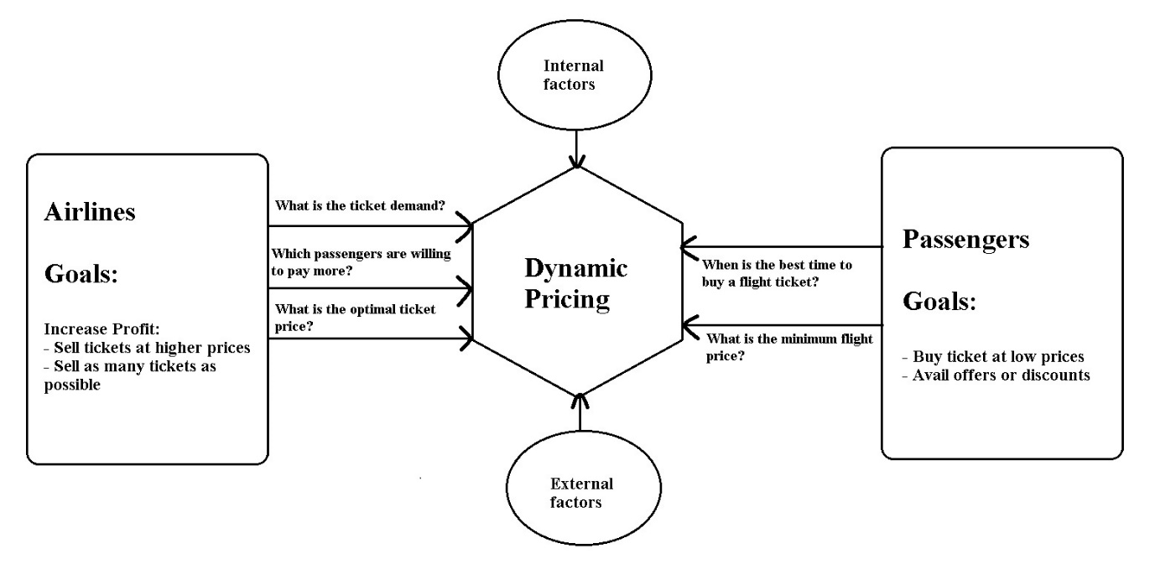

* **Conceptual Background of the Domain Problem**

Airline companies use complex algorithms to calculate flight prices given various conditions present at that particular time. These methods take financial, marketing, and various social factors into account to predict flight prices. Nowadays, the number of people using flights has increased significantly. It is difficult for airlines to maintain prices since prices change dynamically due to different conditions. That’s why we will try to use machine learning to solve this problem. This can help airlines by predicting what prices they can maintain. It can also help customers to predict future flight prices and plan their journey accordingly.

* **Review of Literature**

As per the requirement of client, I have scrapped the data from online sites and based on that data I have did analysis like for based on which feature of my data prices are changing. and checked the relationship of flight price with all the feature like what flight he

should choose.

* **Motivation for the Problem Undertaken**

I have worked on this on the bases of client requirements and followed all the steps till model deployment.

**Analytical Problem Framing**

* **Mathematical/ Analytical Modeling of the Problem**

In our scrapped dataset, our target variable "Flight_Prices " is a continuous variable. Therefore, we will be handling this modelling problem as regression.

This project is done in three parts:

* Data Collection
* Data Analysis
* Model Building

**1. Data Collection**

You have to scrape at least 1500 rows of data. You can scrape more data as well, it’s up to you, More the data better the model. In this section you have to scrape the data of flights from different websites (yatra.com, skyscanner.com, official websites of airlines, etc). The number of columns for data doesn’t have limit, it’s up to you and your creativity. Generally, these columns are airline name, date of journey, source, destination, route, departure time, arrival time, duration, total stops and the target variable price. You can make changes to it, you can add or you can remove some columns, it completely depends on the website from which you are fetching the data.

**2. Data Analysis**

After cleaning the data, you have to do some analysis on the data. Do airfares change frequently? Do they move in small increments or in large jumps? Do they tend to go up or down over time? What is the best time to buy so that the consumer can save the most by taking the least risk? Does price increase as we get near to departure date? Is Indigo cheaper than Jet Airways? Are morning flights expensive?

**3. Model Building**

After collecting the data, you need to build a machine learning model. Before model building do all data pre-processing steps. Try different models with different hyper parameters and select the best model.

Follow the complete life cycle of data science. Include all the steps like

1. Data Cleaning

2. Exploratory Data Analysis

3. Data Pre-processing

4. Model Building

5. Model Evaluation

6. Selecting the best model

* **Data Sources and their formats**

The dataset is in the form of CSV (Comma Separated Value) format and consists of 9 columns (8 features and 1 label) with 5805 number of records as explained below:

* Airline_Names : This shows the list of all the Airline Names for which the data got scraped
* Departure_Time : In this column we have the timings of every flight departure
* Arrival_Time : Here in this column we have the timings of every flight arrival
* Flight_Duration : We can see the total duration of a flight that it took to fly from the source to the destination
* Source_Place : Gives us the name of the source place where the flight journey began
* Destination_Place : Shows us the name of the destination place where the flight journey ended
* Meal_Availability : Provides us with the information on type of meal that the passenger is eligible for
* Number_Of_Stops : Lists the number of stops the flight is going to take to complete the entire journey
* Flight_Prices : Finally we have our label column that has the ticket prices for the aircraft journey

We can see our dataset includes a target label "Used Car Price" column and the remaining feature columns can be used to determine or help in predicting the price of the used cars. Since price is a continuous value it makes this to be a Regression problem!

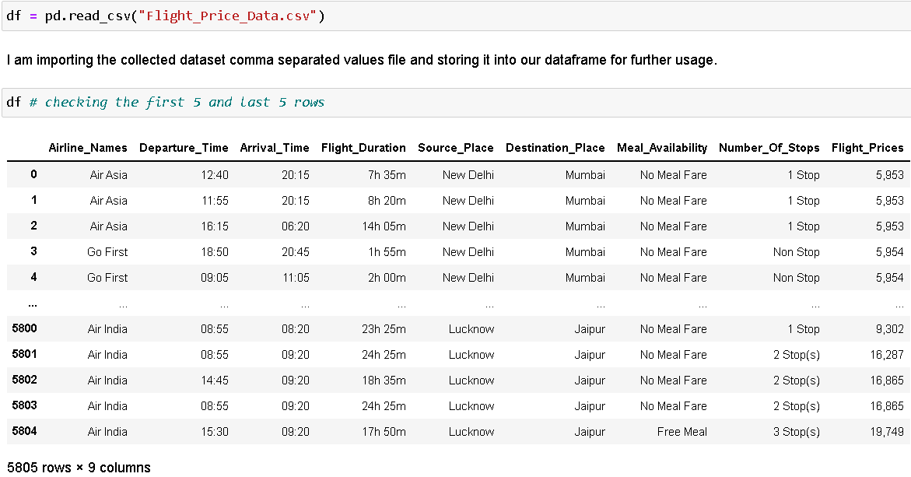

* **Data Preprocessing Done**

For the data pre-processing step, I checked through the dataframe for missing values and renamed values that needed a better meaningful name.

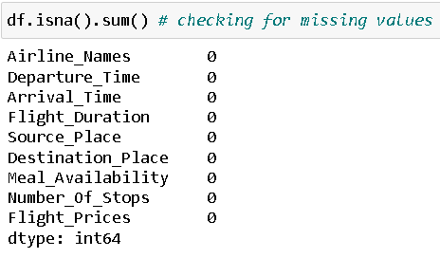

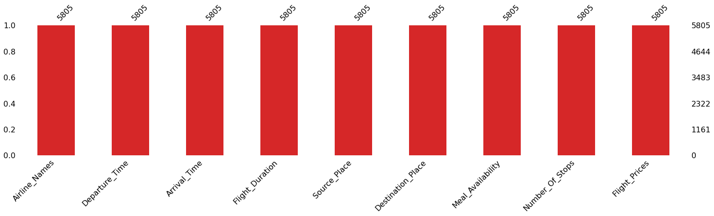

Checked the datatype details for each column to understand the numeric ones and its further conversion process.

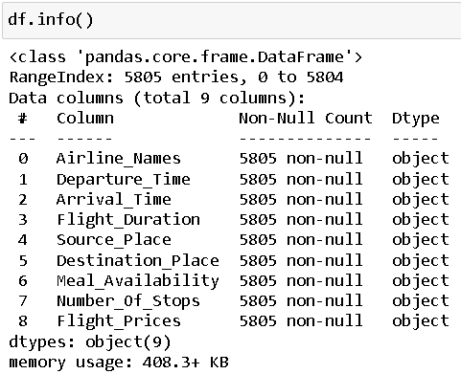

I also took a look at all the unique value present in each of the columns and then decided to view the details for those column values that had less than 10 categories.

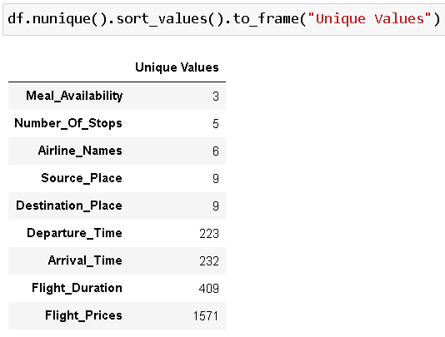

The various data processing performed on our data set are shown below with the code.

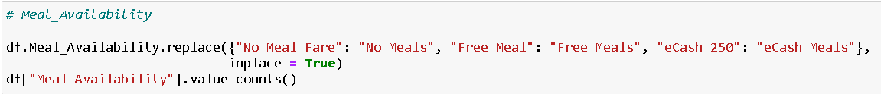

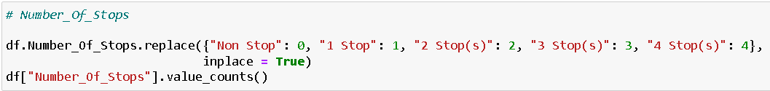

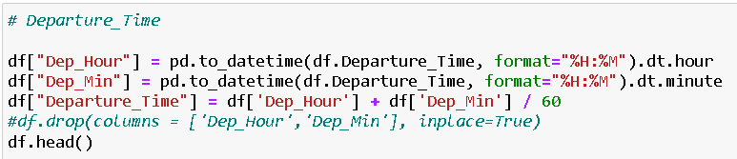

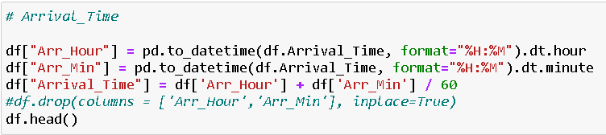

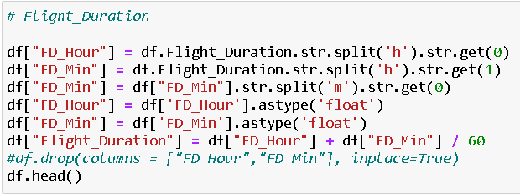

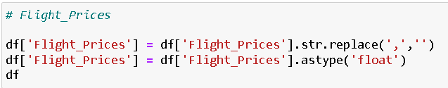

I then used the “describe” method to check the count, mean, standard deviation, minimum, maximum, 25%, 50% and 75% quartile data.

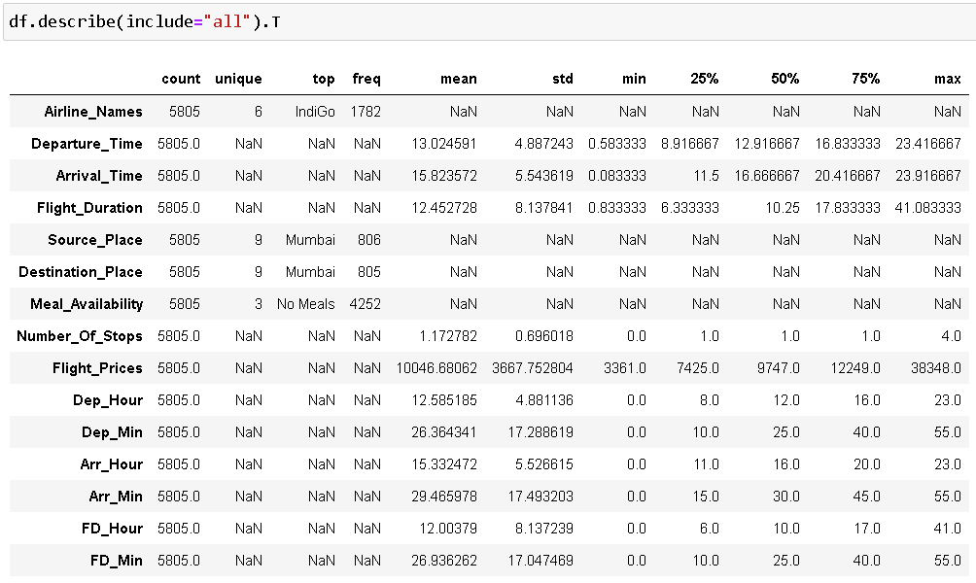

Took a visual on just the numeric part as well and saw just the maximum value for Flight_Prices column at a higher scale.

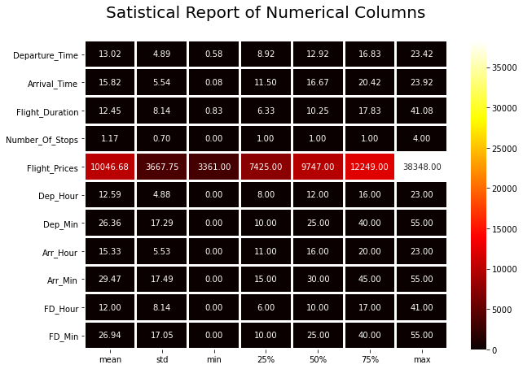

* **Data Inputs- Logic- Output Relationships**

The input data were initially all object datatype so had to clean the data by removing unwanted information like “h” and “m” from Flight_Duration column and ensuring the numeric data are converted accordingly. I then used Ordinal Encoding method to convert all the categorical feature columns to numeric format.

Code:

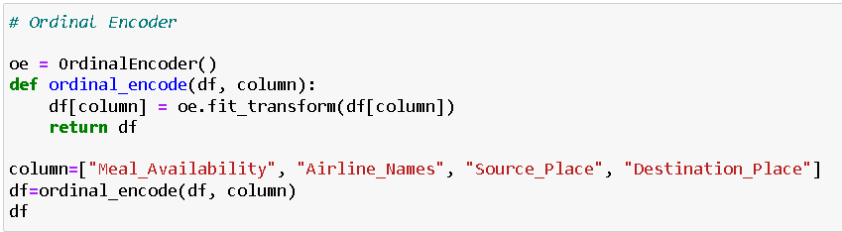

Since we had mostly categorical feature data we did not have to worry about outliers and skewness concerns.

* **State the set of assumptions (if any) related to the problem under consideration**

Pricing in the airline industry is often compared to a brain game between carriers and passengers where each party pursues the best rates. Carrier’s love selling tickets at the highest price possible — while still not losing consumers to competitors. Passengers are crazy about buying flights at the lowest cost available — while not missing the chance to get on board. All this makes flight prices fluctuant and hard to predict. But nothing is impossible for people armed with intellect and algorithms.

There are two main use cases of flight price prediction in the travel industry. OTAs and other travel platforms integrate this feature to attract more visitors looking for the best rates. Airlines employ the technology to forecast rates of competitors and adjust their pricing strategies accordingly.

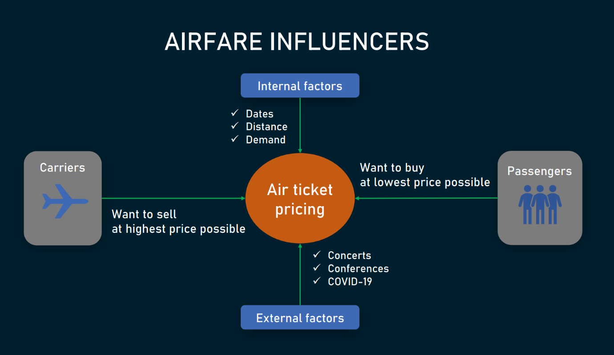

A passenger-side predictor proposed by an OTA suggests the best time to buy a ticket so that travellers can make informed decisions. Carriers, on their end, try to find out the optimal price they should set to maximize revenue while remaining competitive.

In both cases, the task is quite challenging because numerous internal and external factors influence airfares.

Internal factors include

* purchase and departure dates,
* seasonality,
* holidays,
* the number of available airlines and flights,
* fare class,
* the current market demand, and
* flight distance.

External factors embrace events going on in the arrival or departure cities — like

* concerts,
* sports competitions,
* festivals,
* terrorist attacks,
* natural disasters,
* political gatherings,
* epidemic outbursts, and
* economic activities.

Though it’s impossible to cover every external eventuality — say, nothing foreshadowed the 2020 coronavirus pandemic in the middle of 2019 — we still can predict quite a lot, using the right data and advanced machine learning (ML) models.

* **Hardware and Software Requirements and Tools Used**

Hardware technology being used.

RAM : 8 GB

CPU : Intel(R) Core(TM) i3-7100U CPU @ 2.40GHz 2.40 GHz

Software technology being used.

Programming language : Python

Distribution : Anaconda Navigator

Browser based language shell : Jupyter Notebook

Libraries/Packages specifically being used.

Pandas, NumPy, matplotlib, seaborn, scikit-learn, pandas-profiling, missingno

**Model/s Development and Evaluation**

* **Identification of possible problem-solving approaches (methods)**

1. Clean the dataset from unwanted scraped details.

2. Rename values with meaningful information.

3. Encoding the categorical data to get numerical input data.

4. Compare different models and identify the suitable model.

5. R2 score is used as the primary evaluation metric.

6. MSE and RMSE are used as secondary metrics.

7. Cross Validation Score was used to ensure there are no overfitting our underfitting models.

* **Testing of Identified Approaches (Algorithms)**

Libraries and Machine Learning Regression models that were used in this project are shown below.

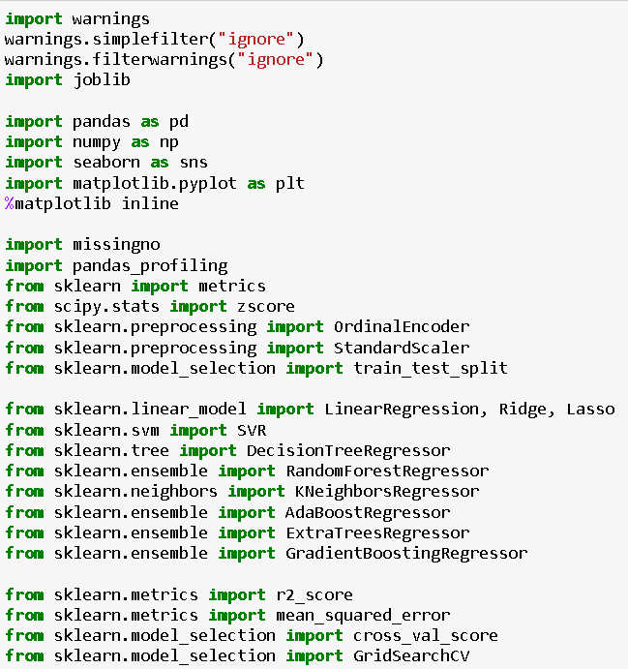

All the regression machine learning algorithms used are:

▪ Linear Regression Model

▪ Ridge Regularization Model

▪ Lasso Regularization Model

▪ Support Vector Regression Model

▪ Decision Tree Regression Model

▪ Random Forest Regression Model

▪ K Neighbours Regression Model

▪ Gradient Boosting Regression Model

▪ Ada Boost Regression Model

▪ Extra Trees Regression Model

* **Run and evaluate selected models**

I created a Regression Machine Leaning Model function incorporating the evaluation metrics so that we can get the required data for all the above models.

Code:

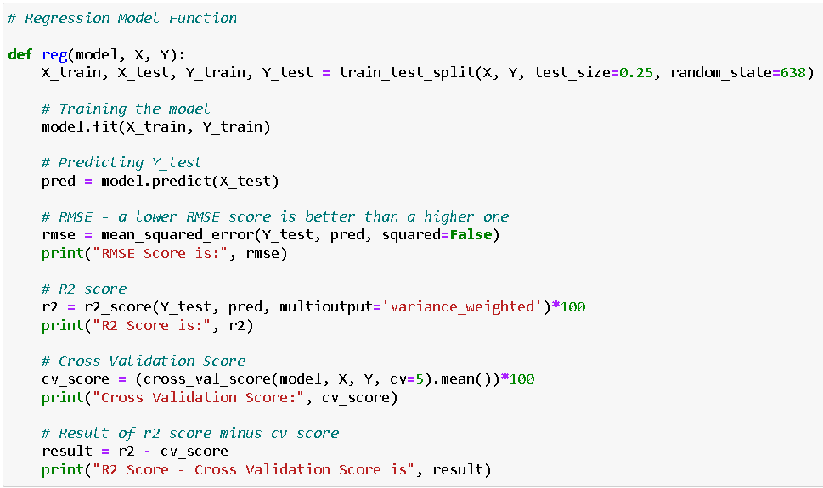

Output:



* **Key Metrics for success in solving problem under consideration**

**RMSE Score:**

Root Mean Square Error (RMSE) is the standard deviation of the residuals (prediction errors). Residuals are a measure of how far from the regression line data points are; RMSE is a measure of how spread out these residuals are. In other words, it tells you how concentrated the data is around the line of best fit.

**R2 Score:**

The R2 score is a very important metric that is used to evaluate the performance of a regression-based machine learning model. It is pronounced as R squared and is also known as the coefficient of determination. It works by measuring the amount of variance in the predictions explained by the dataset.

**Cross Validation Score:**

Cross-validation is a statistical method used to estimate the skill of machine learning models. It is commonly used in applied machine learning to compare and select a model for a given predictive modelling problem because it is easy to understand, easy to implement, and results in skill estimates that generally have a lower bias than other methods. The k-fold cross validation is a procedure used to estimate the skill of the model on new data. There are common tactics that you can use to select the value of k for your dataset (I have used 5-fold validation in this project). There are commonly used variations on cross-validation such as stratified and repeated that are available in scikit-learn.

**Hyper Parameter Tuning:**

In machine learning, hyperparameter optimization or tuning is the problem of choosing a set of optimal hyperparameters for a learning algorithm. A hyperparameter is a parameter whose value is used to control the learning process. By contrast, the values of other parameters (typically node weights) are learned.

Code:

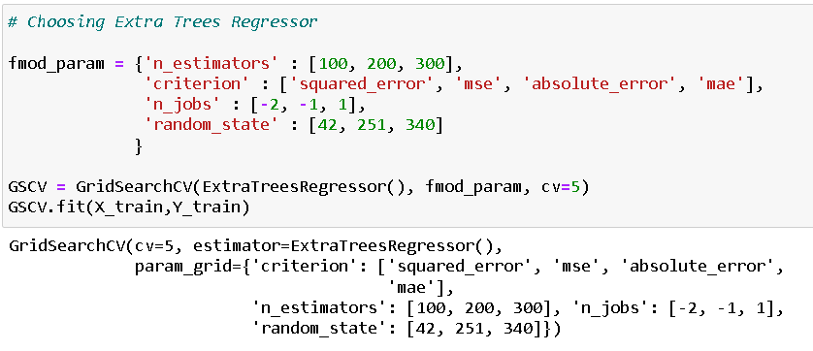

Final model score after plugging in the best parameter values:

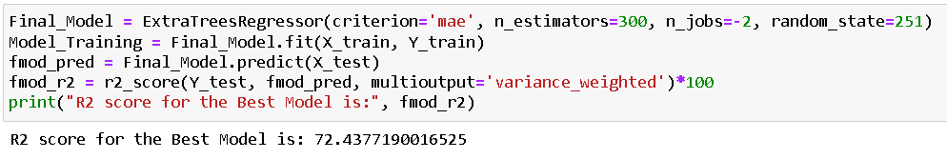

* **Visualizations**

I used the pandas profiling feature to generate an initial detailed report on my dataframe values. It gives us various information on the rendered dataset like the correlations, missing values, duplicate rows, variable types, memory size etc. This assists us in further detailed visualization separating each part one by one comparing and research for the impacts on the prediction of our target label from all the available feature columns.

Code:



Output:

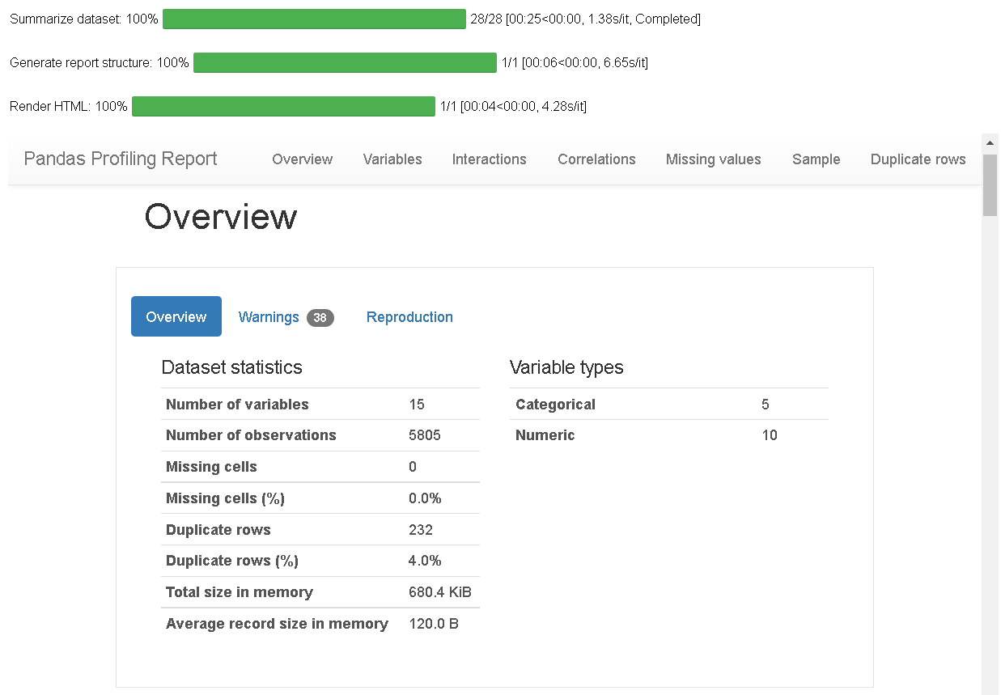

I generated count plots, bar plots, pair plots, heatmap and others to visualise the datapoint present in our column records.



Observation on Fig 1:

There are 73.25% flights that mostly serve no meals in their domestic journey since they are of short distances and duration

We can see that 17.47% flights serve free meals which are probably for tickets that include those prices and meal services

Finally, there are 9.29% flights which offer the eCash meals option that can be redeemed to purchase food during long journey flights mostly with multiple stops

Observation on Fig 2:

Highest number of airlines preferred by people are Indigo covering 30.7% of the total record

We can see that Air India is quite close to the first one and a close competitor standing at the second position holding 28.22% of the total record

At third place we have Vistara airlines that covers 26.08% of total record in our airline data

Airlines Go First, Air Asia and SpiceJet are the least used by people covering 8.48%, 3.67% and 2.86% respectively

Observation on Fig 3:

The departure area or source place highly used or people majorly flying from the city is "Mumbai" covering 13.88% record in the column

We see that "Bangalore" is a close second wherein it covers 13.01% records in the column

Other two famous locations where people chose to fly from are "New Delhi" and "Kolkata" covering 12.89% and 12.82% respectively

The least travel from location is "Jaipur" where I believe not many people chose to travel from unless they are returning from a vacation there and hence covers 7.36% of record in the column

Observation on Fig 4:

Just as in case of departure area even in terms of arrival area or destination place people prefer to fly towards the city "Mumbai" covering 13.87% of record

Again, in a similar fashion "Bangalore" city is a close second destination that people like to fly towards covering 13.54% record in the column

Surprisingly we have "Hyderabad" city taking the third place for destination that people prefer landing covering 13.07% of record

Finally, similar to the departure location the least travel to area is "Jaipur" and it covers 5.24% record in the column

Observation on Fig 5:

People generally buy flight tickets that have 1 stop layover covering 63.67% rows in the column

Next in line are 2 stop layovers which cover 19.88% rows

Here we can see that the 0 stop flights availability is around 11.94% of the total record

In domestic flight we rarely see 3 or 4 stop layovers and therefore they cover 4.2% and 0.31% of total rows in the column respectively

Code:

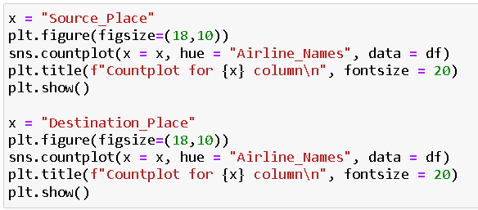

Output:



Observation:

Checking out the Source place details for each and every airline we can see that Mumbai city has the highest number of departure flights for Air India airlines

Go First, Indigo and Air India are the airlines that are used in almost all the cities to depart while the other airlines do not cover some or the other city

Looking at the Destination place details for each and every airline we can see that Hyderabad city has the highest number of arrival flights for Air India airlines

Once again, we can observe that Go First, Indigo and Air India are the leading airlines that are used in almost all cities to arrive while the other airlines miss out on some or the other regions

Overall, I can notice that Air India and Indigo flights do quite well and can be used for arrival and departure to and from any location in India

Code:

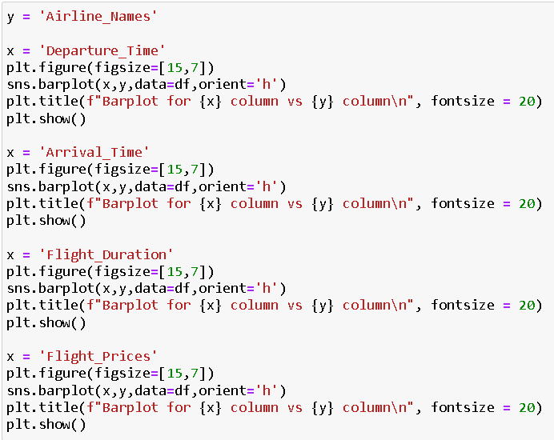

Output:



Observation:

When we observe the barplot for Departure time vs Airline we can see that Air Asia has the highest departure time while IndiGo has the lowest departure time

Considering the barplot for Arrival time vs Airline we can see that IndiGo has the highest arrival time while Air Asia and SpiceJet have the lowest arrival time

Taking a look at the barplot for Flight duration vs Airline we observe that Ai India has the highest flight duration while Indigo has the lowest flight duration collectively

Comparing the bar plots for Flight prices vs Airline we can clearly see that Vistara and Air India have very high flight prices while the other airlines IndiGo, SpiceJet, Go First and Air Asia lie in a similar price bracket where Air Asia has the lowest fare

Code:

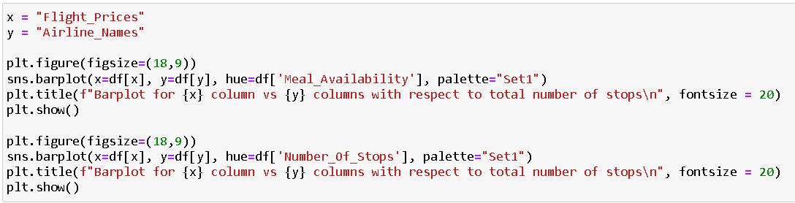

Output:



Observation:

Vistara and Air India are the only airlines that have free meal service on their flights but also have a very high no meal record

Also, the eCash meal options do not work for Vistara and Air India flights and they have very high flight prices compared to their competitors

If we see a trend the flights with 0 stops or rather direct flights for every airline is cheaper when compared to 1 or more layovers

And flights with 2 and 3 stops have a considerably high price and number of flights available in those records are high too

Only Air India provides flights with 4 stop layovers even in a domestic environment

SpiceJet on the other hand only has flights available with 0 and 1 stop layovers

Code:

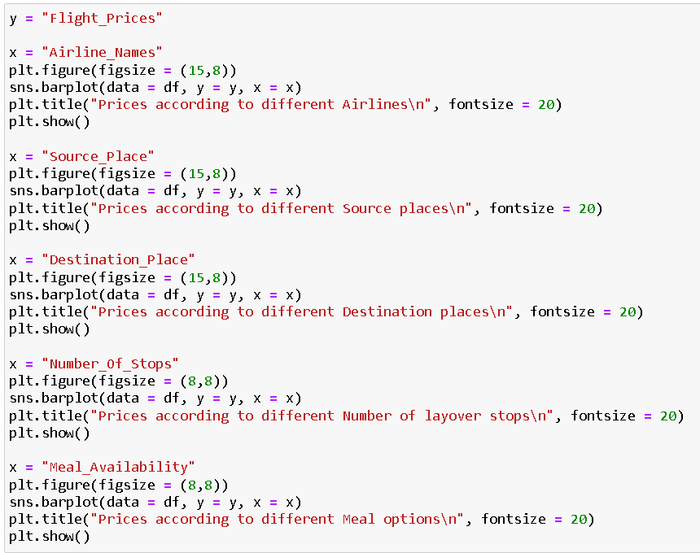

Output:



Observation:

Airfares in Vistara and Air India are pretty high when compared to other airlines as they provide free meal service which probably is just meal cost included in the tickets

Flight prices when departing from cities like Kolkata and Chennai have higher price range but the others are around the similar range a bit lesser in pricing but not providing a huge difference as such

Similarly, prices when arriving from cities Kolkata and Chennai have high price range however the highest recorded is for Lucknow city and the rest fall in similar price bracket again not making any huge difference in savings

When we consider the layovers for pricing situation then obviously direct flights are cheaper when compared to flights that have 1 or more stops

As per the data collected, we see that free meal service flight tickets cost the highest as compared to no meal service flight tickets and the lowest price observed are for eCash meal service wherein the frequent flyers can use their flight points as discounts on the ticket prices

Code:

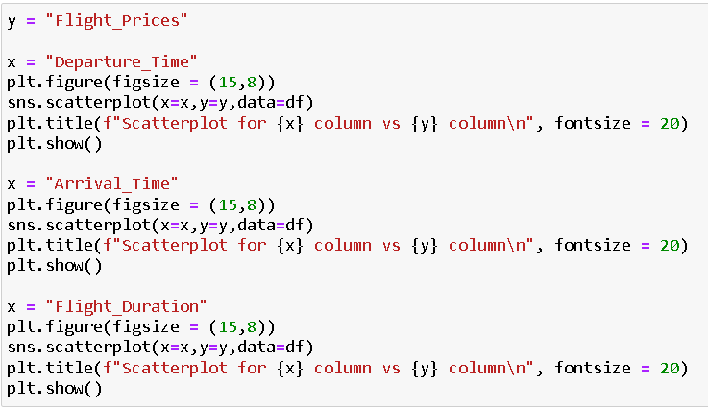

Output:



Observation:

In the above scatter plot, we see the comparison where flight prices are the highest during peak hours as compared to late hours or specifically graveyard timings for departure

We can see a similar trend in flight price scatter plot details when it comes to arrival timings where we see a decrease in prices between 1:00 hrs and 6:00 hrs

Finally, as the overall flight duration increases the flight prices increase too and that makes direct flight depart and arrive in a relatively shorter period of time

Code:



Output:

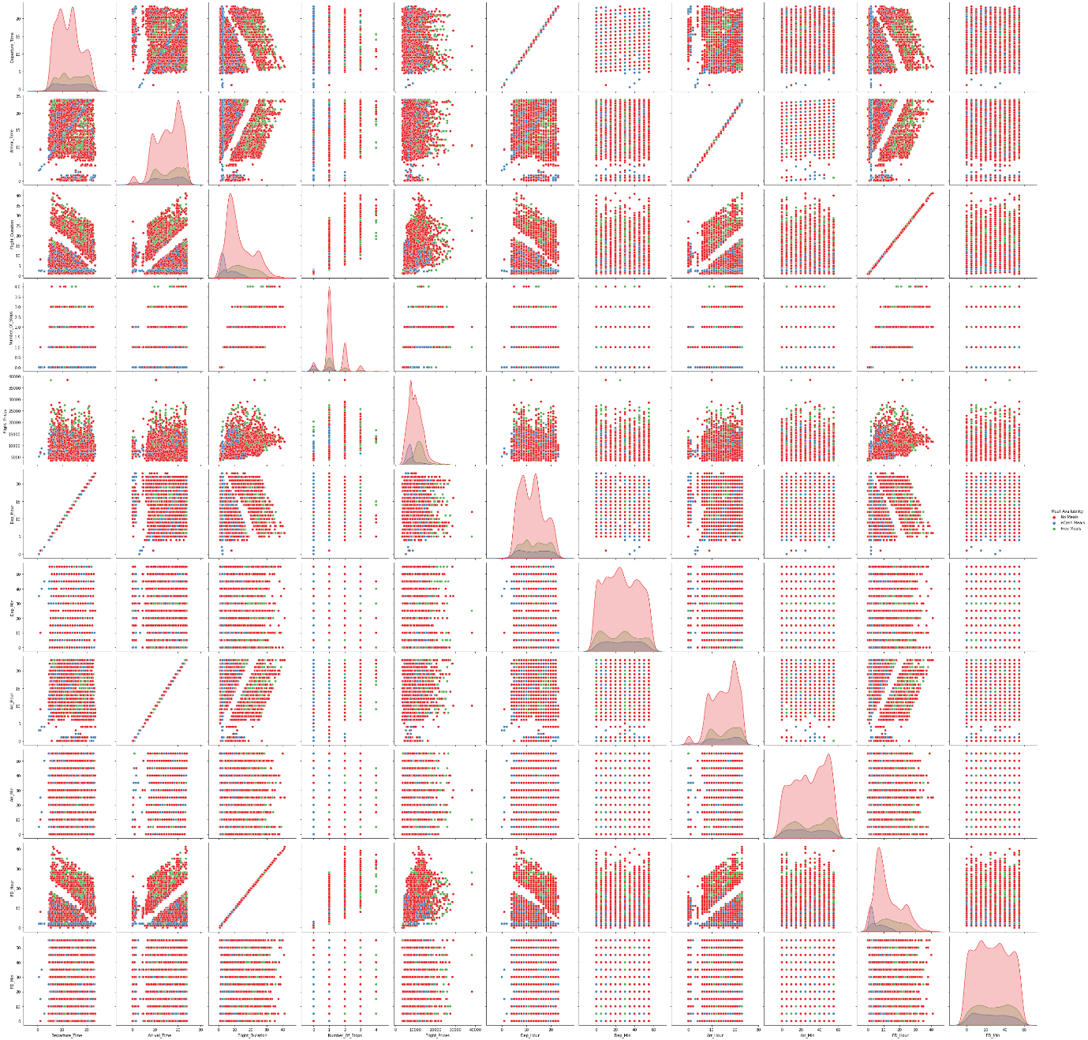

Code:

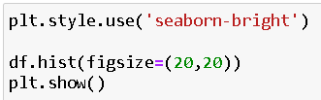

Output:

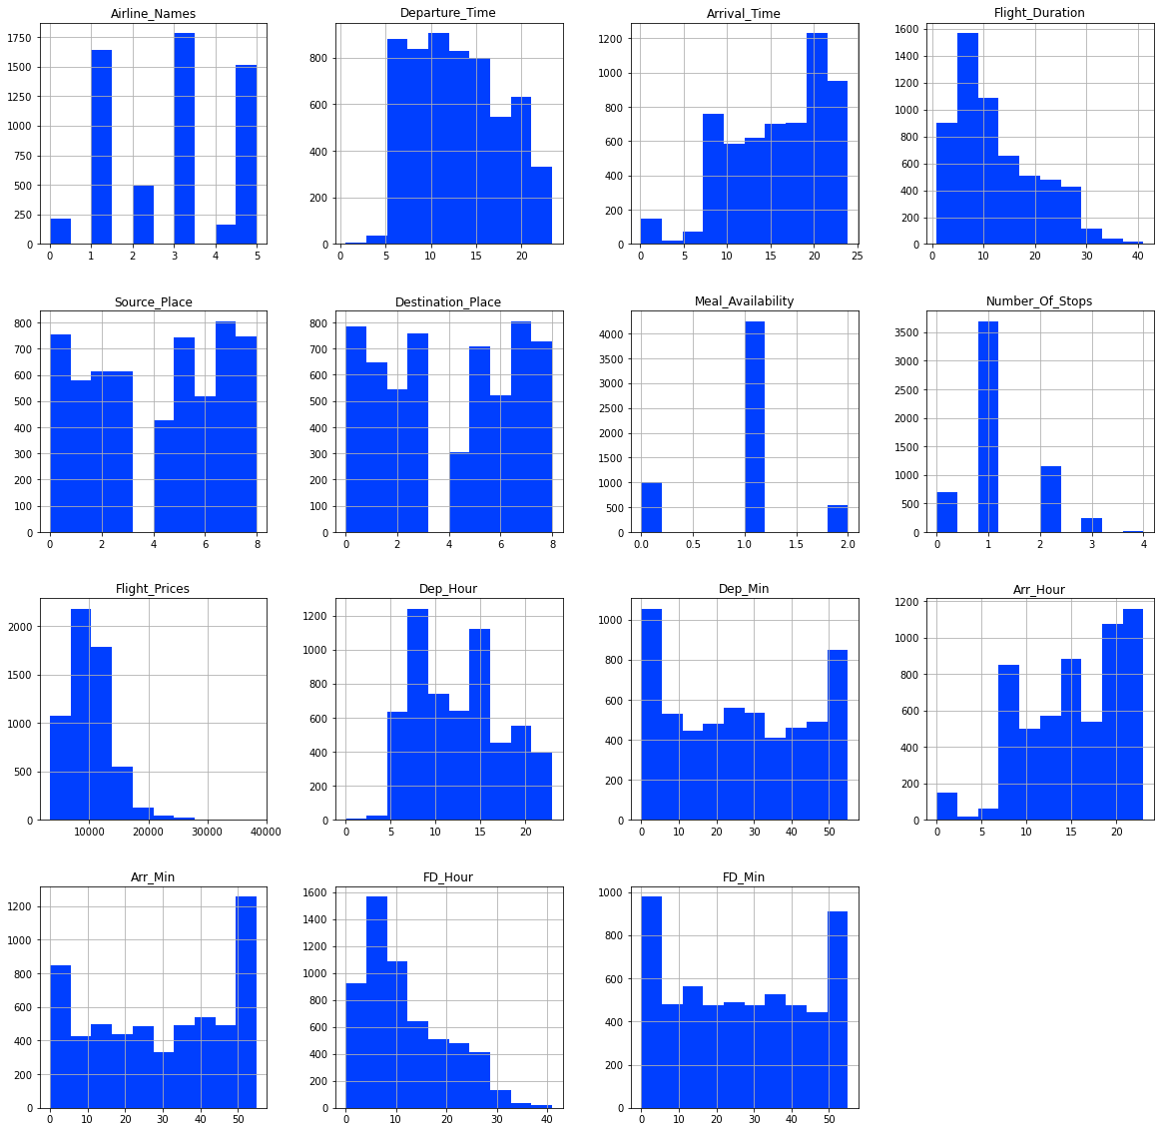

Code:

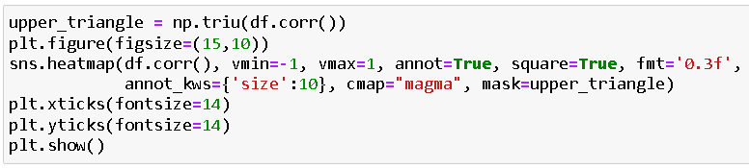

Output:

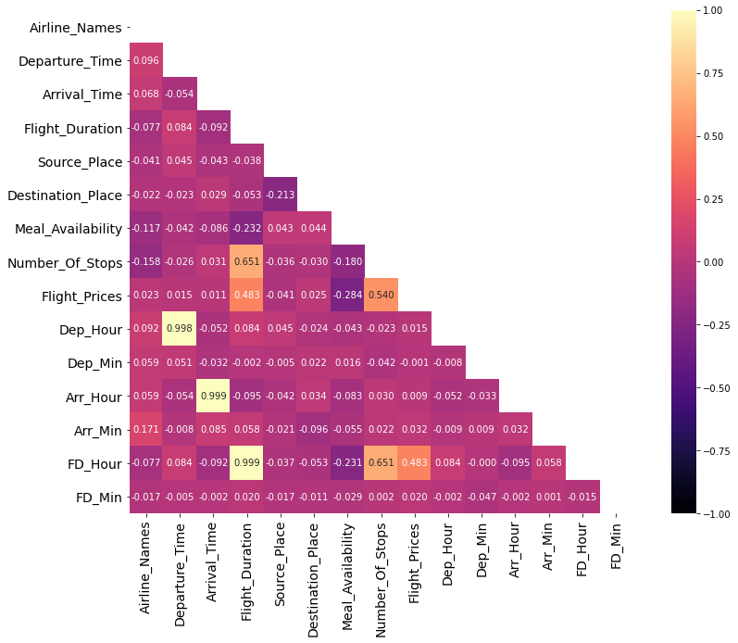

Code:

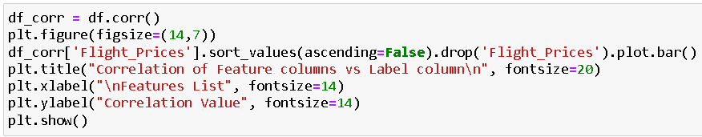

Output:

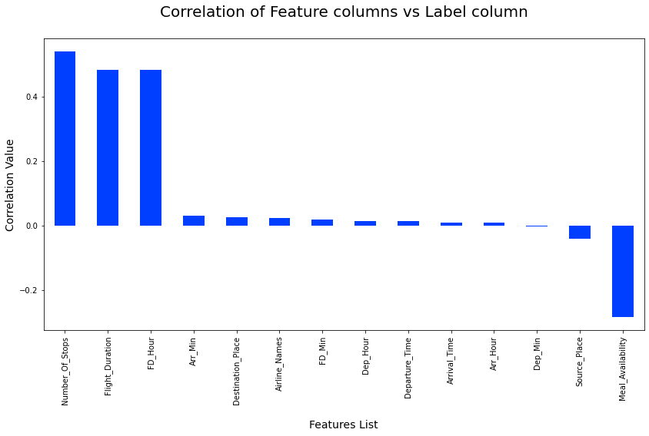

Outliers Code:

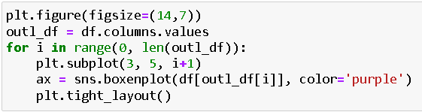

Output:

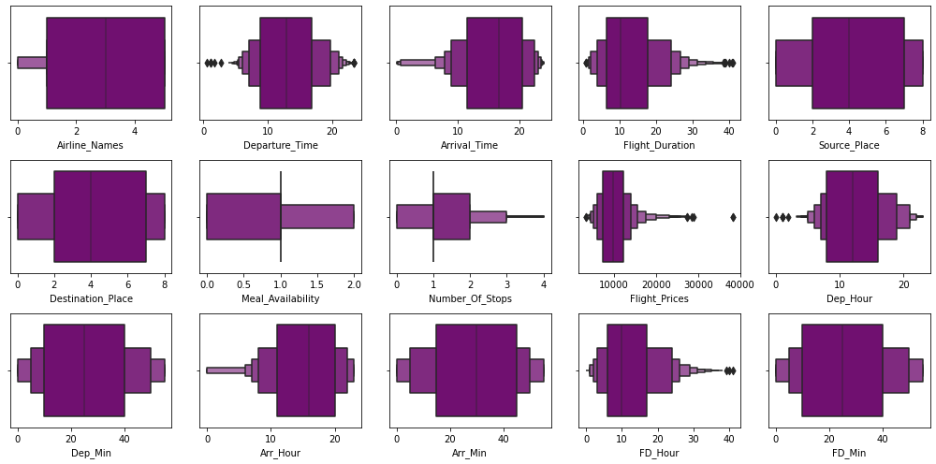

Skewness Code:

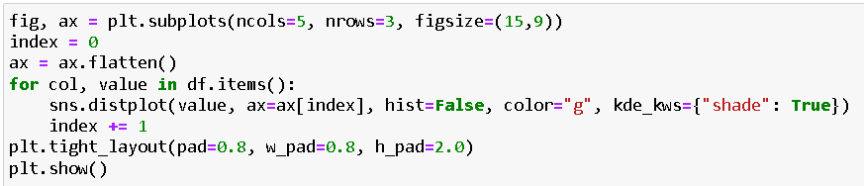

Output:

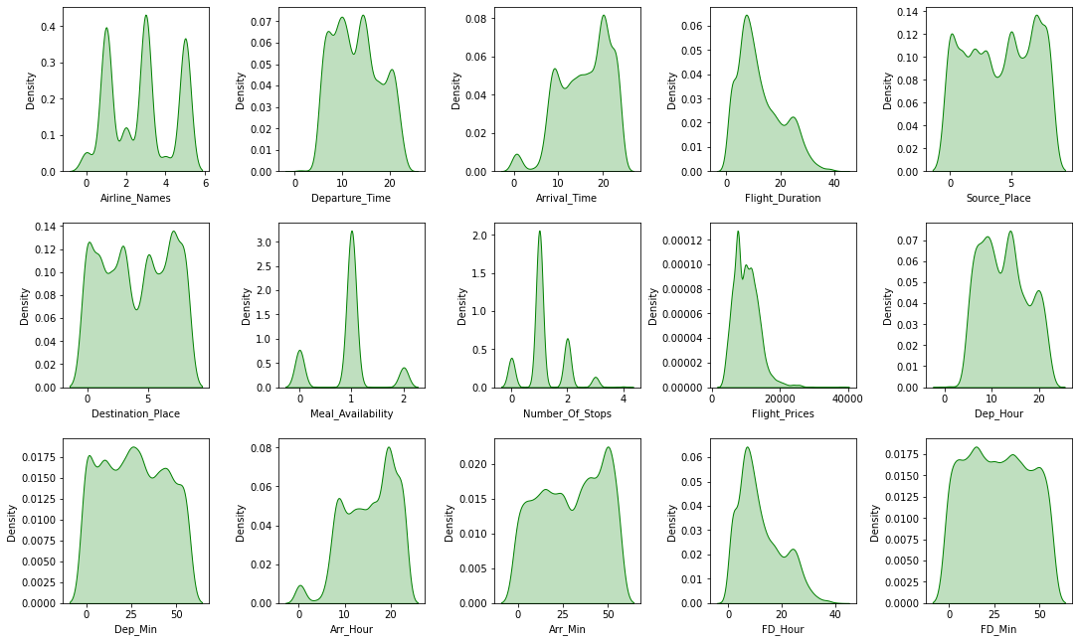

Importance Graph Code:

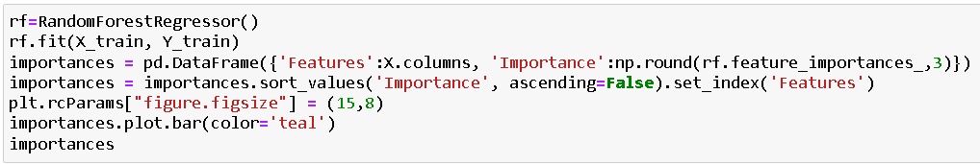

Output:

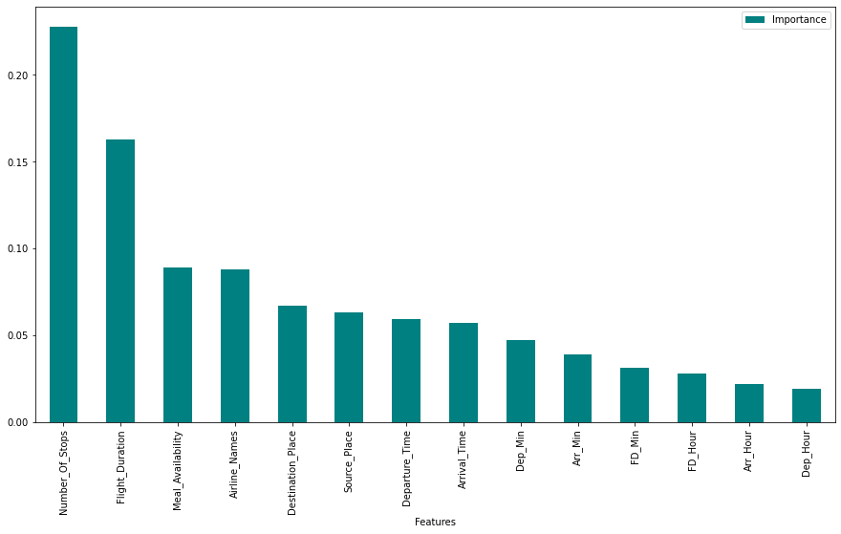

* **Interpretation of the Results**

From the above EDA we can easily understand the relationship between features and we can even see which things are affecting the price of flights. These methods take financial, marketing, and various social factors into account to predict flight prices. Nowadays, the number of people using flights has increased significantly. It is difficult for airlines to maintain prices since prices change dynamically due to different conditions. That’s why we have tried to use machine learning to solve this problem. This can help airlines by predicting what prices they can maintain. It can also help customers to predict future flight prices and plan their journey accordingly.

**CONCLUSION**

* **Key Findings and Conclusions of the Study**

In this project we have scraped the flight data from airline webpages. Then the comma separated value file is loaded into a data frame. Luckily, we don't have any missing values in our data set. Looking at the data set we understand that there are some features needs to be processed like converting the data types and get the actual value from the string entries from the time related columns. After the data is been processed, I have done some EDA to understand the relation among features and the target variable. Features like flight duration, number of stops during the journey and the availability of meals are playing major role in predicting the prices of the flights. As we have seen, the prediction is showing a similar relationship with the actual price from the scrapped data set. This means the model predicted correctly and it could help airlines by predicting what prices they can maintain. It could also help customers to predict future flight prices and plan the journey accordingly because it is difficult for airlines to maintain prices since it changes dynamically due to different conditions. Hence by using Machine Learning techniques we can solve this problem. The above research will help our client to study the latest flight price market and with the help of the model built he can easily predict the price ranges of the flight, and also will helps him to understand Based on what factors the fight price is decided.

* **Learning Outcomes of the Study in respect of Data Science**

Visualization part helped me to understand the data as it provides graphical representation of huge data. It assisted me to understand the feature importance, outliers/skewness detection and to compare the independent-dependent features. Data cleaning is the most important part of model building and therefore before model building, I made sure the data is cleaned. I have generated multiple regression machine learning models to get the best model wherein I found Extra Trees Regressor Model being the best based on the metrics I have used.

* **Limitations of this work and Scope for Future Work**

As looking at the features we came to know that the numbers of features are very less, due to which we are getting somewhat lower R2 scores. Some algorithms are facing over-fitting problem which may be because of a smaller number of features in our dataset. We can get a better R2 score than now by fetching some more features from the web scraping by that we may also reduce the over fitting problem in our models. Another limitation of the study is that in the volatile changing market we have taken the data, to be more precise we have taken the data at the time of pandemic and recent data, so when the pandemic ends the market correction might happen slowly. So, based on that again the deciding factors of it may change and we have shortlisted and taken these data from the important cities across India. If the customer is from the different country our model might fail to predict the accuracy prize of that flight.

